FILE MANAGER

**END TERM REPORT**

***By***

**Etneni Pruthvi Raj , Jilla Sahith , Sai Charan Reddy**

Section: K19PT

Group No: 7

Roll Numbers: 51,54,24



**Department of Intelligent Systems,**

**School of Computer Science Engineering,**

**Lovely Professional University, Jalandhar**

November, 2020

**TABLE OF CONTENTS**

|  |  |
| --- | --- |
| * Student Declaration * Bonafide Certificate * Acknowledgement * Introduction * GitHub repository of the project * Description of the project and supporting images |  |

**Student Declaration**

This is to declare that this report has been written by me/us. No part of the report is copied from other sources. All information included from other sources have been duly acknowledged. I/We aver that if any part of the report is found to be copied, I/we are shall take full responsibility for it.

Signature:

Name: Etneni Pruthvi Raj

Jilla Sahith

Sai Charan Reddy

Roll Number: 51

54

24

Place: Phagwara

Date: 30/10/2020

**BONAFIDE CERTIFICATE**

Certified that this project report “FILE MANGER” is the bonafide work of “Etneni Pruthvi Raj , Jilla Sahith ,Sai Charan Reddy”.

” who carried out the project work under my supervision.

### <<Signature of the Supervisor>>(Due to Covid 19, signature is exempted )

<<Name of supervisor>>

<<Academic Designation>>

<<ID of Supervisor>>

<<Department of Supervisor>>

Acknowledgement

I would like to express my special thanks of gratitude to my teacher ***Dr. Dhanpratap Singh*** who gave us the golden opportunity to do this wonderful **project** on the topic FILE MANAGER, which also helped us in doing a lot of Research and learn python programming language i came to know about so many ideas to make it happen. And we thank our self **(Etneni Pruthvi Raj,Jilla Sahith ,Sai Charan Reddy)** with all good team work. we made on time and learned a lot .

Introduction

Python offers various modules to create graphics programs. Out of these Tkinter provides the fastest and easiest way to create GUI applications.

The following steps are involved in creating a tkinter application:

Importing the tkinter module.

Creation of the main window (container).

Addition of widgets to the main window

Applying the event Trigger on widgets like buttons, etc.

Creating the File Explorer

In order to do so, we have to import the filedialog module from Tkinter. The Filedialog module will help you open, save files or directories.

In order to open a file explorer, we have to use the method, askopenfilename(). This function creates a file dialog object.

GitHub repository of the project

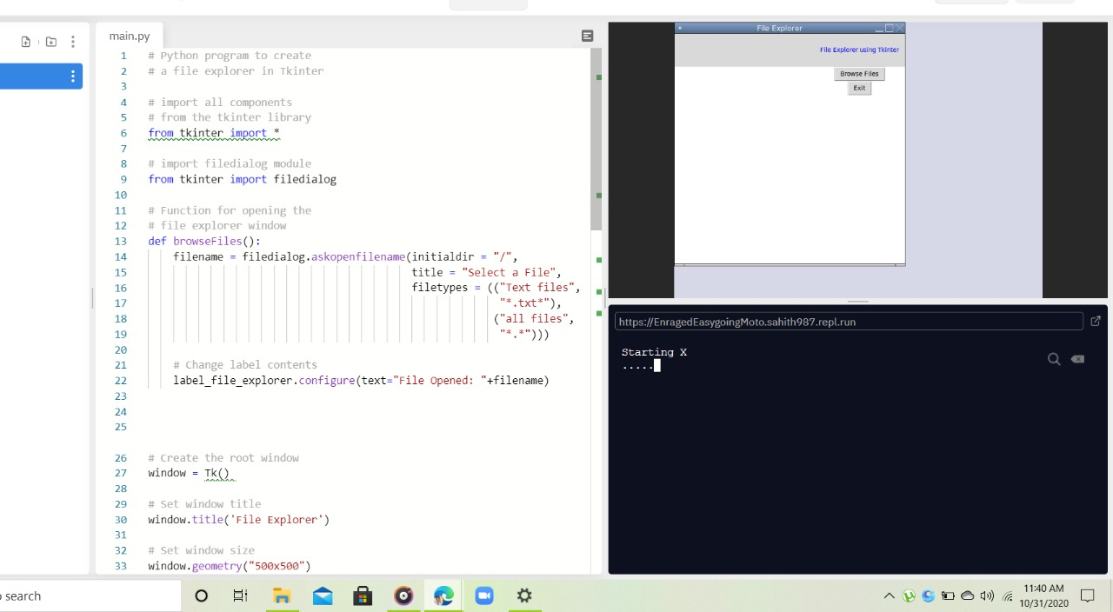

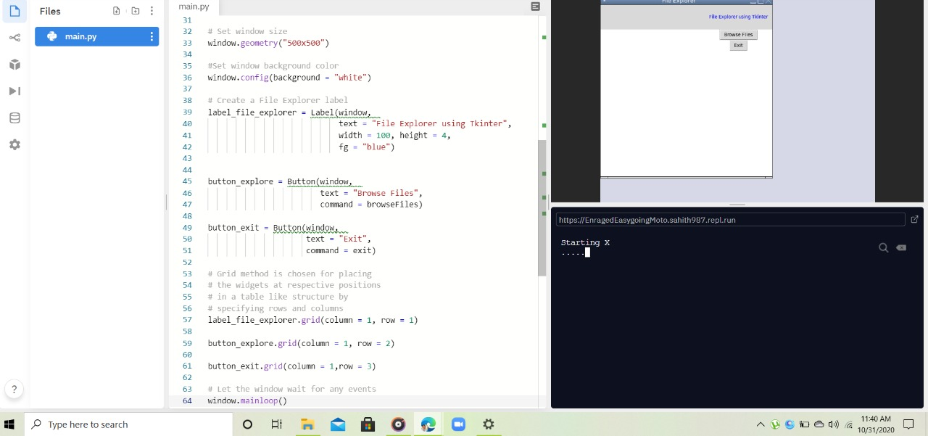

Code

And supporting images

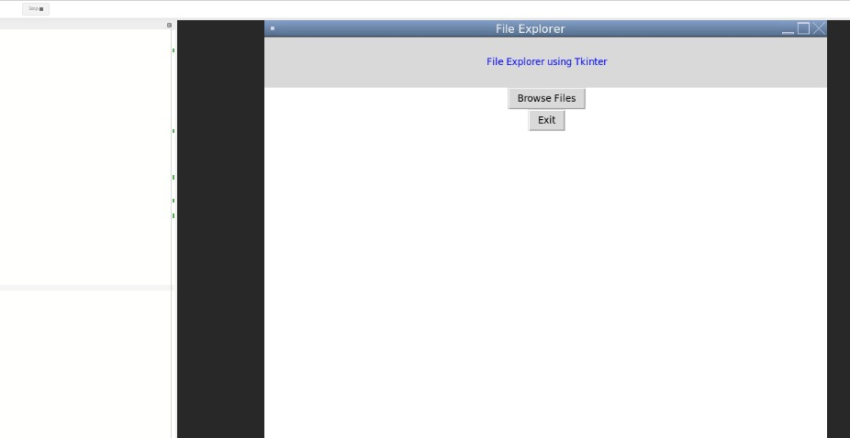

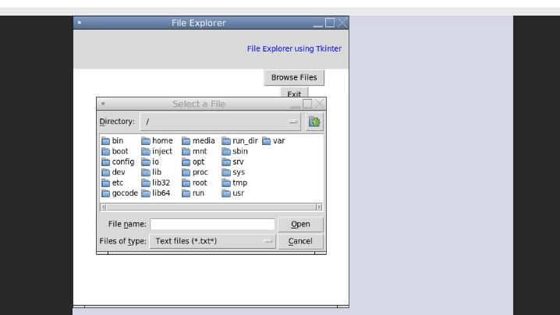

This is the final output